**Inspiring and Motivating Individuals (C1)**

**week 1**

A model for creating and communicating your vision can be done starting with three questions:

* why do we do what we do?
* what does success look like?
* how must we act to ensure success?

The checklist for creating and communicating your vision can be:

What you say!

* refer to fundamental values
* use stories and analogies
* use rhetorical questions and 3 part lists

Verbal and non-verbal in communication

* vary your intonation, volume and pitch
* smile
* maintain an open body posture

Summary: It addresses the importance of a company having a vision and how a leader must convey this message in order to motivate his team.

**week 2**

Think of a goal you had in the past:

* Was the goal effective?
* If the goal was effective, what made it effective?
* If the goal was not effective, why wasn’t it effective?

If you accept the goal the performance is usually higher, since you see value on it including for more complex work.

Stretching goals can cause/promote:

* unethical behaviour
* dissatisfaction

SMART goals:

* Specific
* Measurable
* Agreed-upon
* Reasonable
* Time-bound

Always good to Increase skill variety and autonomy, implies in inspiring people on doing something different and giving a sense of control of the process, respectively.

Summary: it addresses how to proper set effective goals and expectations.

**week 3**

More engaged employees implies on more profitability and productivity companies.

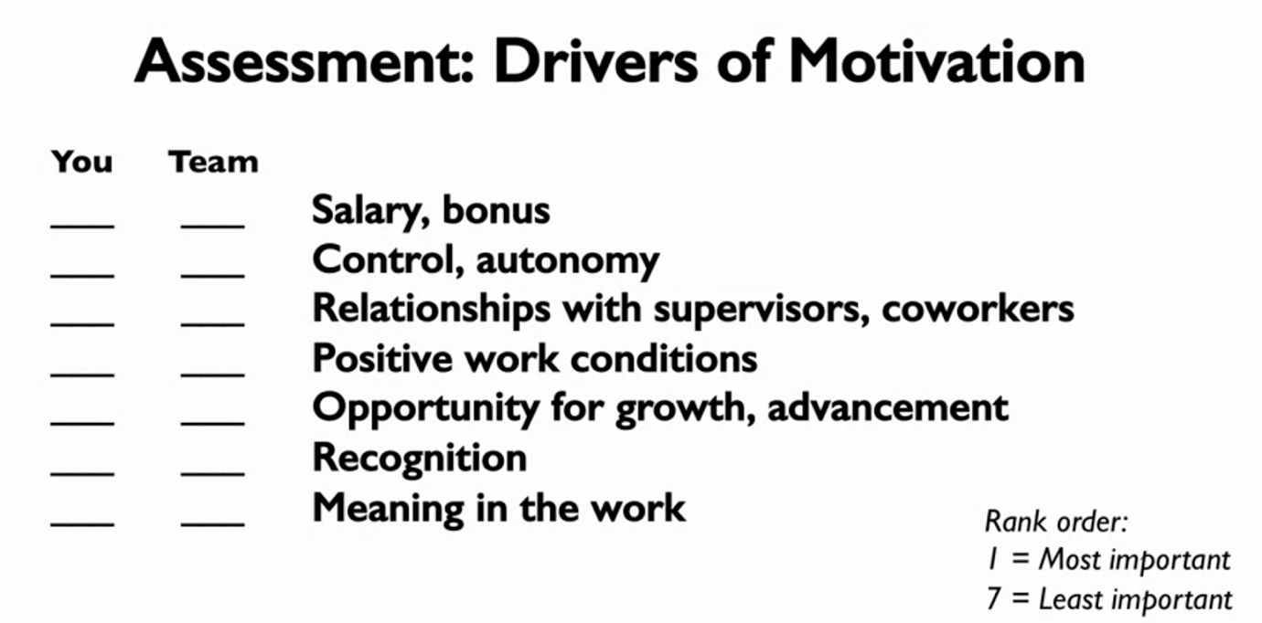

Rewarding people for an intrinsically interesting task undermines their motivation to engage in the task.

Intrinsic motivation example: to focus on learning and mastery.

Extrinsic motivation example: to focus on salary adjustment and job title.

4 major traps on motivating people:

* #1 assuming people are like us (social projection)
* #2 assuming extrinsic rewards have a linear relationship with happiness (more money doesn’t mean more happiness)
* #3 not aligning rewards with desired outcomes
* #4 ignoring social comparison and fairness concerns

Summary: it addresses how to proper inspire and motivate individuals.

**week 4**

Applying equity principles:

* Attain congruence in perceptions of inputs
* Make sure inputs are relevant and important for the organization
* Recognize the rewards people value
* Communicate
* Strive for equity in the long-term

When discussed about reinforcement rewards, it’s stated two types, fixed interval/ratio and variable interval/ratio.

There is a parallel of slot machines and reinforcement rewards, the so called variable interval (receiving a reward after time intervals of different length).

Conclusion on reinforcement:

* Ratio reinforcement schedules outperform interval reinforcement schedules.
* Variable reinforcement schedules outperform their fixed counterparts.

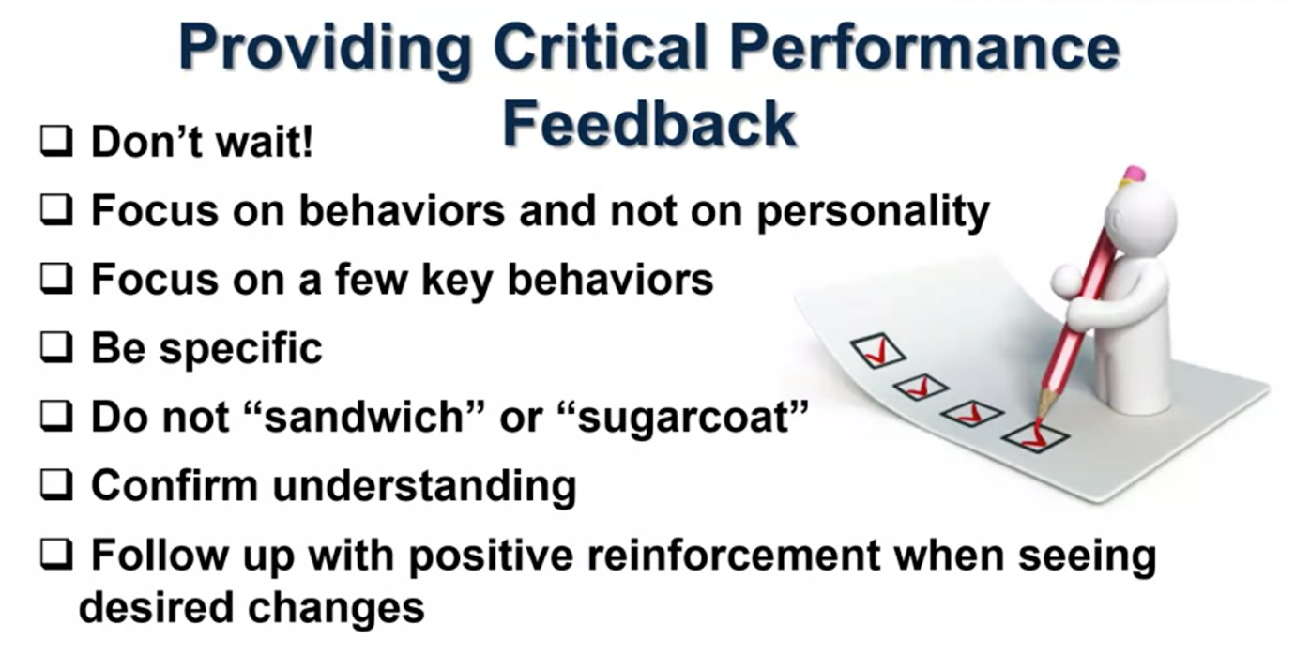

Summary: it addresses how to use rewards and feedback to drive behavior.